

**Project Report**

on

**GPT3 with Voice Command Capabilities**

Submitted by

**Project Members**

Gaurav Untawale (1032201414)

Akshita Vijayvergiya (1032201451)

Priyal Agrawal (1032201406)

Durva Chawan (1032201697)

Akshat Raj (1032201725)

**Under the Internal Guidance of**

**Prof. Aparna Kamble**

**School of Computer Engineering and Technology**

**MIT World Peace University, Kothrud,**

**Pune 411 038, Maharashtra - India**

**2022-2023**



### **SCHOOL OF COMPUTER ENGINEERING AND TECHNOLOGY**

**C E R T I F I C A T E**

This is to certify that, Gaurav Untawale Akshita Vijayvergiya Priyal Agrawal

Durva Chawan

Akshat Raj

of BTech.( Computer Science & Engineering) have completed their project titled “*Gpt3 with voice command capabilities”* and have submitted this Mini Project Report towards fulfillment of the requirement for the Degree-Bachelor of Computer Science & Engineering (TY. BTech-CSE) for the academic year 2022-2023.

**[Dr./ Prof. Aparna Kamble] [Dr. Vrushali Kulkarni]**

Project Guide Program Head

School of CET School of CET

MIT World Peace University, Pune MIT World Peace University, Pune

Internal Examiner:

External Examiner:

**Date:**

Acknowledgement

We would like to express our gratitude to Professor Aparna Kamble for their guidance and support throughout the development of the voice-controlled interface for the Chat-GPT3 project. Their valuable insights and expertise have greatly contributed to the success of this project. We also extend our appreciation to the faculty and staff at MIT World Peace University for their assistance and resources.

Gaurav Untawale

Akshita Vijayvergiya

Priyal Agrawal

Durva Chawan

Akshat Raj

Abstract

The integration of voice command capabilities into GPT-3, a state-of-the-art language model developed by OpenAI, has revolutionized the way humans interact with artificial intelligence (AI) systems.

Voice command technology allows users to interact with GPT-3 using natural language spoken commands, enabling a more seamless and intuitive user experience. This abstract provides an overview of the capabilities, benefits, and potential applications of GPT-3 with voice command capabilities.

GPT-3 with voice command capabilities leverages advanced natural language processing (NLP) and speech recognition technologies to understand and interpret voice commands in real-time. Users can simply speak their commands to GPT-3, which then processes the input and generates responses accordingly.

The benefits of GPT-3 with voice command capabilities are numerous. First and foremost, it enhances accessibility by providing a means of interaction for individuals with disabilities or limited mobility. It also improves user experience by enabling more intuitive and conversational interactions with AI systems, which can result in increased user engagement and satisfaction.

Additionally, voice command capabilities can enhance productivity by allowing users to perform tasks more efficiently and effectively, such as composing emails, scheduling appointments, or searching for information, all through voice commands.

In conclusion, the integration of voice command capabilities into GPT-3 has transformed the way humans interact with AI systems, providing a more natural, intuitive, and convenient means of communication.

The benefits of GPT-3 with voice command capabilities are numerous, and its potential applications are vast, promising to revolutionize various industries and domains.

List of Figures

| 1.1 | Overview…………………………………………….. | 3 |
| --- | --- | --- |
| 1.2 | Block Diagram……………………………………….. | 4 |

List of Tables

| 1.1 | Information ………………………………………… | 3 |
| --- | --- | --- |
| 2.1 | Literature Survey…………………………………… | 10 |

Contents

Abstract . . . . . . . . . . . . . . . . . . . . . . . . . . . . . . . . . . . . . . . . . . . . . . . . …….……. ..I

List of Figures . . . . . . . . . . . . . . . . . . . . . . . . . . . . . . . . . . . . . . . . . . . . ….…… …II

List of Tables . . . . . . . . . . . . . . . . . . . . . . . . . . . . . . . . . . . . . . . . . ….. . ….…... . III

| 1 | Introduction | | | 8 |
| --- | --- | --- | --- | --- |
| 2 | Literature Survey | | | 9 |
| 3 | Problem Statement | | | 13 |
| 4 | Project Requirements | | | 15 |
| 5 | System Analysis Proposed Architecture/ high level design of the project | | | 19 |
| 6 | Project Plan | | | 24 |
| 7 | Implementation | | | 26 |
| 8 | References | | | 32 |
| 9 | Conclusion | | | 33 |

Chapter 1

Introduction

Have you ever talked to a virtual assistant like Siri or Alexa? These assistants can help you with a wide range of tasks, from setting reminders to playing music. However, they are limited in their capabilities, and often require specific commands to perform certain actions. In recent years, language models like GPT-3 have been developed to generate human-like text.

These models have the potential to revolutionize how we interact with technology, but currently, they cannot understand voice commands. In this research paper, we explore the potential of integrating voice command capabilities into GPT-3, to improve its usability and expand its use in various domains. Our goal is to determine whether this is feasible, and what challenges need to be overcome to make it a reality. We hope that our research will contribute to the development of more sophisticated language models that can understand voice commands and enhance the user experience.

GPT (Generative Pre-trained Transformer) is a machine learning algorithm that has significantly impacted various aspects of our lives in recent years. It is a language model based on neural networks that has been trained on vast amounts of text data, enabling it to generate human-like text in response to a given prompt. Some of the ways in which GPT has affected our lives include language translation, chatbots and virtual assistants, content creation, and personalization.

To enhance the efficiency of the GPT model, several modules and techniques are employed, such as transfer learning, attention mechanism, layer normalization, beam search, and dropout. These modules and techniques have been proven to be effective in improving the performance of GPT models, thereby making them more accurate and efficient in their operations. Furthermore, various upgrades and modifications to the GPT model are continuously being developed and implemented to keep up with the ever-evolving technological landscape.

Chapter 2

Literature Survey

[1]The paper proposes a chatbot system for healthcare that utilizes Artificial Intelligence to improve patient experience, increase efficiency, and reduce costs. The system uses NLP and machine learning techniques to provide accurate and relevant responses to user queries. The paper provides a comprehensive review of existing literature on chatbots in healthcare and describes the development and usability testing of the system. Overall, the paper provides valuable insights for future research and practical applications in the field of healthcare.

The paper proposes an AI-based chatbot system that provides personalized health recommendations to users based on their input. However, there is a research gap in developing AI-based chatbots that can accurately identify symptoms and provide personalized health recommendations. The proposed system uses machine learning to analyze user input and provide accurate recommendations, but further studies are needed to evaluate its effectiveness. While the system has the potential to enhance healthcare delivery and accessibility, future research should explore potential limitations and ethical concerns associated with the use of AI and chatbots in healthcare.

The paper presents a healthcare chatbot system that incorporates NLP, machine learning, and a knowledge base to provide personalized health recommendations to users. The chatbot understands natural language queries, extracts relevant information, and uses a medical knowledge base to provide accurate recommendations.

The paper describes the use of several algorithms in the chatbot system for healthcare, including tokenization, stop words removal, feature extraction based on N-gram TFIDF, N-gram for text compression, and cosine similarity for sentence similarity. The system uses TF-IDF to calculate the weight of each term in the sentence and retrieves the matched sentence to display the answer to the user's query. The paper highlights the use of these algorithms to improve the speed and effectiveness of the chatbot in providing accurate health recommendations.

[2]AI has become an integral part of everyday life, with virtual assistants and voice-based technology increasing in popularity. AI chatbots and voice assistants have the potential to delegate routine tasks and increase efficiency in business processes. Recent advancements in GPT technology have opened up possibilities for various fields. ChatGPT, a revolutionary chatbot developed by OpenAI, can engage in conscious dialogue with users and perform a variety of tasks. It differs from other text neural networks with its "memory" that allows it to remember details of the conversation and build responses based on the information provided by the user. The paper highlights the positive potential of AI-enabled chatbots, including their ability to improve customer service, save time, and enhance user experience.

AI has become an integral part of everyday life, with virtual assistants and voice-based technology increasing in popularity. AI chatbots and voice assistants have the potential to delegate routine tasks and increase efficiency in business processes. Recent advancements in GPT technology have opened up possibilities for various fields. ChatGPT, a revolutionary chatbot developed by OpenAI, can engage in conscious dialogue with users and perform a variety of tasks. It differs from other text neural networks with its "memory" that allows it to remember details of the conversation and build responses based on the information provided by the user. The paper highlights the positive potential of AI-enabled chatbots, including their ability to improve customer service, save time, and enhance user experience.

The paper discusses the potential of combining Chat GPT technology with voice assistant algorithms to enhance AI-powered customer service. It explains the key differences between chatbots and voice assistants and highlights the advantages of using voice assistants in digital banking. The paper cites machine learning technologies, cloud computing, natural language processing, and optimized algorithms as essential components of voice assistants. However, it does not specify any particular algorithm used in the voice assistant technology.

[3]This paper introduces a new approach to enhance human-human communication by detecting and responding to emotional states. The authors provide a clear and detailed methodology, including information on the dataset, model architecture, and evaluation metrics. They conducted experiments to evaluate their framework, demonstrating its effectiveness in real-world scenarios. The paper also discusses the strengths and weaknesses of their approach and suggests future research directions. Overall, this paper provides valuable insights into emotion-aware dialogue frameworks and makes a significant contribution to the field of communication research.

One potential research gap of this paper could be the lack of a comparative analysis with existing emotion-aware dialogue frameworks. While the authors compare their proposed framework with several baseline models, they do not provide a direct comparison with other emotion-aware dialogue frameworks that have been proposed in the literature. A comparative analysis could provide a better understanding of the strengths and weaknesses of the proposed approach compared to existing solutions, which could help identify areas for further improvement.

FaceChat is an advanced chatbot that enables users to engage in a face-to-face dialogue experience through a web browser. The system has been designed to detect nonverbal cues such as facial expressions and tone of voice, providing a more comprehensive insight into the user's emotional state. The use of WebRTC technology and GPU-based servers optimizes the system's pipeline, resulting in a smoother and more efficient user experience.

The FaceChat system uses various advanced technologies, including WebRTC, a voice activity detector that has been pre-trained, a face detection model based on neural networks, a chatbot powered by GPT-3, a natural text-to-speech synthesizer called VITS, and OpenAI's whisper for accurate automatic speech recognition. The entire backend of the system is developed using Python, which can be easily integrated with popular deep learning frameworks, allowing for future development of multimodal dialogue systems through the collection of video and speech data.

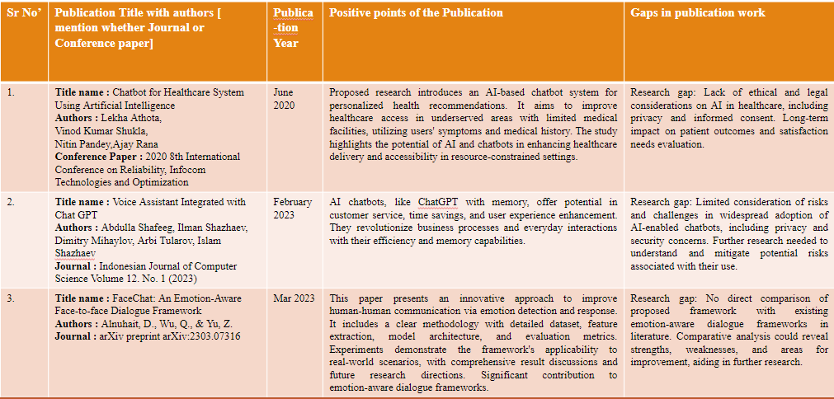

Chapter 3.

Problem Statement

## Create voice-controlled interface for Chat-GPT3 to improve user experience, accessibility, and broaden applications.

The problem statement is to develop a voice-controlled interface for the Chat-GPT3 language model, which is currently only accessible through text input. The goal is to provide a more convenient and natural way for users to interact with the Chat-GPT3 model, allowing them to speak their questions and receive responses through voice commands.

This will require integrating speech recognition technology to understand and interpret spoken commands, and generating responses using text-to-speech technology. The interface must handle diverse accents, dialects, and languages and optimize speed and accuracy. This will improve user experience, engagement, accessibility for people with disabilities and broaden its applications.

1. Project Scope:

The scope of the project is to develop a voice-controlled interface for Chat-GPT3, which will enable users to interact with the chatbot using their voice commands. The project aims to improve the user experience and accessibility of the chatbot while broadening its applications.

1. Project Assumptions:

It is assumed that the existing Chat-GPT3 system has a robust and reliable backend that can handle voice commands. The project also assumes that the voice-controlled interface will be integrated with the existing system seamlessly, without any major technical challenges.

1. Project Limitations:

The project has limitations in terms of the accuracy and reliability of voice recognition technology. There may be instances where the system fails to recognize voice commands accurately, which may lead to a suboptimal user experience. The project also has limitations in terms of the diversity of accents and dialects that the system can recognize, as these may vary based on the location and culture of the users.

1. Project Objectives:

The objectives of the project are to develop a voice-controlled interface for Chat-GPT3 that can accurately recognize voice commands and provide an improved user experience. The project aims to make the chatbot more accessible to a wider range of users and broaden its applications, such as in hands-free scenarios or for users with disabilities.

Chapter 4

Project Requirements

Project Resources

o Human Resources

1. Project Manager: responsible for overseeing the project, ensuring that it stays within budget and on schedule, and coordinating the efforts of the development team.
2. Software Developers: responsible for writing the code that will be used to develop the software, integrating the APIs, and ensuring that the software meets the project requirements.
3. Machine Learning Engineer: responsible for developing and training the machine learning models that will be used in the project.
4. UI/UX Designer: responsible for designing the user interface and user experience of the software.

o Reusable Software Components (e.g. Data preprocessing applied at many locations

then specify it here)

1. Speech Recognition Library: a pre-built library that can be used to convert speech to text. This library could be used instead of developing a custom solution for speech to text conversion.
2. Text-to-Speech (TTS) Engine: a pre-built TTS engine that can be used to convert text to speech. This could be used instead of developing a custom solution for text to speech conversion using Google API.
3. Natural Language Processing (NLP) Library: a pre-built NLP library that can be used to extract information from text. This could be used instead of developing a custom solution for information extraction using ApenaAI API.

o Software &amp; h/w requirements

Functional Specifications:

o Interfaces:

o External interfaces required

1. Whisper API:
   * 1. Whisper is a speech recognition API that allows developers to convert spoken words to text.
     2. To use Whisper, you will need to sign up for a Whisper API key by creating an account and being approved by the provider.
     3. Once you have the API key, you can use it to make API requests to Whisper.
2. OpenAI API:
   * 1. OpenAI is a research organization that develops cutting-edge artificial intelligence technologies.
     2. Their API allows developers to access these technologies, such as natural language processing and machine learning models.
     3. To use the OpenAI API, you will need to sign up for an API key by creating an account and being approved by OpenAI.
     4. Once you have the API key, you can use it to make API requests to OpenAI.
3. Network connection:
   * 1. To make API requests to OpenAI and Whisper, you will need a stable network connection.
     2. Make sure to test your project in different network conditions to ensure it works properly.

o Internal interfaces required

1. Python:
   1. Python is an interpreted high-level programming language that is widely used in many different domains.
   2. It is a requirement for many popular libraries and frameworks, including Django and pyttsx3.
2. pyttsx3:
   1. pyttsx3 is a Python library that provides an interface for text-to-speech conversion using different speech engines.

o Communication interfaces

1. RESTful API:
   1. A communication interface that allows the software to interact with other systems or services over the internet.
   2. The software could expose RESTful endpoints to allow other systems to request speech-to-text conversion, text-to-speech generation, or information extraction.
2. Websockets:
   1. A communication interface that enables real-time communication between the software and other systems or services.
   2. This could be used to allow users to receive text-to-speech output or to provide real-time updates on the status of speech-to-text conversion or information extraction.
3. Message Queue:
   1. A communication interface that allows systems or services to send and receive messages asynchronously. This could be used to queue requests for speech-to-text conversion or information extraction, or to receive text-to-speech output.
4. Email/SMS Integration: a communication interface that allows the software to send notifications or alerts to users via email or SMS. This could be used to notify users when speech-to-text conversion or information extraction is complete, or to provide updates on the status of the software.

o Graphical User Interfaces

1. Django: Django is a popular web framework for Python that makes it easy to build web applications.
2. Heroku CLI: Heroku is a cloud platform that allows developers to deploy, manage, and scale web applications. To deploy your Django web application on Heroku, you will need to use the Heroku Command Line Interface (CLI).

Chapter 5

System Analysis Proposed Architecture/ high level design of the project

1. Design Consideration
   1. Speech Recognition Accuracy: Ensuring accurate interpretation of diverse accents, dialects, and languages in spoken commands.
   2. Text-to-Speech Naturalness: Choosing a natural-sounding speech output for an engaging user experience.
   3. System Latency: Managing delays to provide real-time or near-real-time interactions.
   4. Scalability and Performance: Designing for multiple concurrent users and large volumes of voice commands.
   5. User Interface Usability: Creating an intuitive and user-friendly interface for easy interaction.
   6. Privacy and Security: Implementing robust measures to protect user data and comply with data protection regulations.
   7. Error Handling: Implementing effective error handling mechanisms for accurate error messages.
   8. Accessibility: Ensuring accessibility for users with disabilities, such as text-based options.
   9. Integration with Chat-GPT3 API/Interface: Seamless integration with Chat-GPT3 API or interface for text input/output.
   10. Cloud-Based Hosting: Selecting a scalable and reliable cloud-based hosting solution for high availability and scalability.
2. Assumption and Dependencies
   1. Assumptions:
3. Reliable speech recognition and text-to-speech technologies are available.
4. Integration with Chat-GPT3 API or interface is possible.
5. Users have internet connectivity to access the cloud-based system.
6. Dependencies:
7. Accuracy of speech recognition affects system performance.
8. Quality of text-to-speech technology impacts the naturalness of generated speech.
9. Availability and reliability of Chat-GPT3 API affect response generation.
10. Dependence on third-party cloud-based infrastructure for hosting and communication.
11. Implementation of privacy and security measures is crucial for protecting user data and ensuring system integrity.
12. General Constraints
    1. Hardware Limitations: The system's performance may be constrained by the capabilities of the devices used for speech recognition, text-to-speech, and hosting.
    2. Language Model Limitations: The underlying Chat-GPT3 language model's capabilities and limitations may impact the system's performance.
    3. Computational Resources: The availability and allocation of computational resources may constrain the system's performance and scalability.
    4. Latency and Response Time: The speed of speech recognition, text-to-speech, and communication with the Chat-GPT3 API may impact the system's real-time responsiveness and user experience.
    5. Accents, Dialects, and Languages: Challenges in accurately recognizing diverse accents, dialects, and languages may affect the system's understanding and response generation.
    6. Development and Deployment Constraints: Limitations in timelines, budgets, and resources may affect the system's design, functionality, and performance.
13. Block Diagram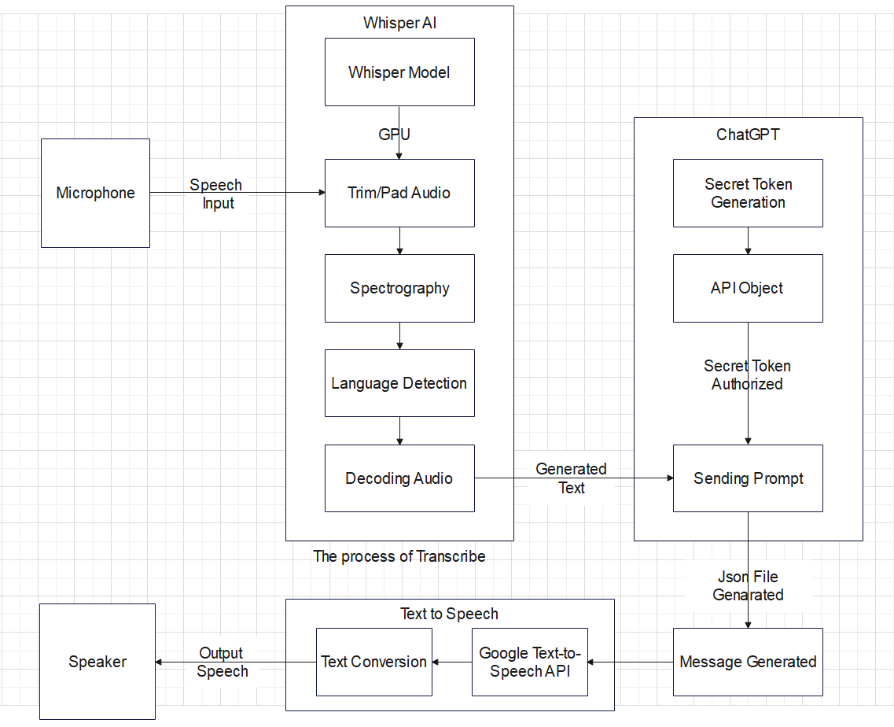

Fig 4.1: Block Diagram for ChatGPT, Whisper ASW and Text-to-Speech

1. System Architecture
   1. **Speech Recognition**: The system uses a module to convert spoken commands into text input for the Chat-GPT3 language model.
   2. **Text-to-Speech**: The system employs a module to convert generated text responses into natural-sounding speech output for the user.
   3. **Chat-GPT3 API/Interface**: The system interacts with the Chat-GPT3 API or interface to send text inputs and receive text outputs, which are then converted into speech using the text-to-speech module.
   4. **Cloud-Based Hosting**: The system is hosted on a cloud-based infrastructure for accessibility and efficient processing.
   5. **User Interface**: The system may include a user interface for users to initiate voice commands, receive audio responses, and provide feedback or input.
   6. **Scalability and Performance**: The system is designed to be scalable and optimized for performance to provide real-time responsiveness and a seamless user experience.
2. Modules of the Project
   1. **Speech Recognition**: Converts spoken commands into text input for the language model.
   2. **Text-to-Speech**: Converts generated text responses into natural-sounding speech output.
   3. **Chat-GPT3 API/Interface**: Facilitates interaction with the Chat-GPT3 API or interface for text inputs and outputs.
   4. **Cloud-Based Hosting**: Hosts the system on a cloud-based infrastructure for accessibility and efficient processing.
   5. **User Interface**: Provides a user-friendly interface for voice commands, audio responses, and user input.
   6. **Scalability and Performance**: Ensures scalability and optimized system performance for real-time responsiveness and a seamless user experience.

Chapter 6.

Project Plan

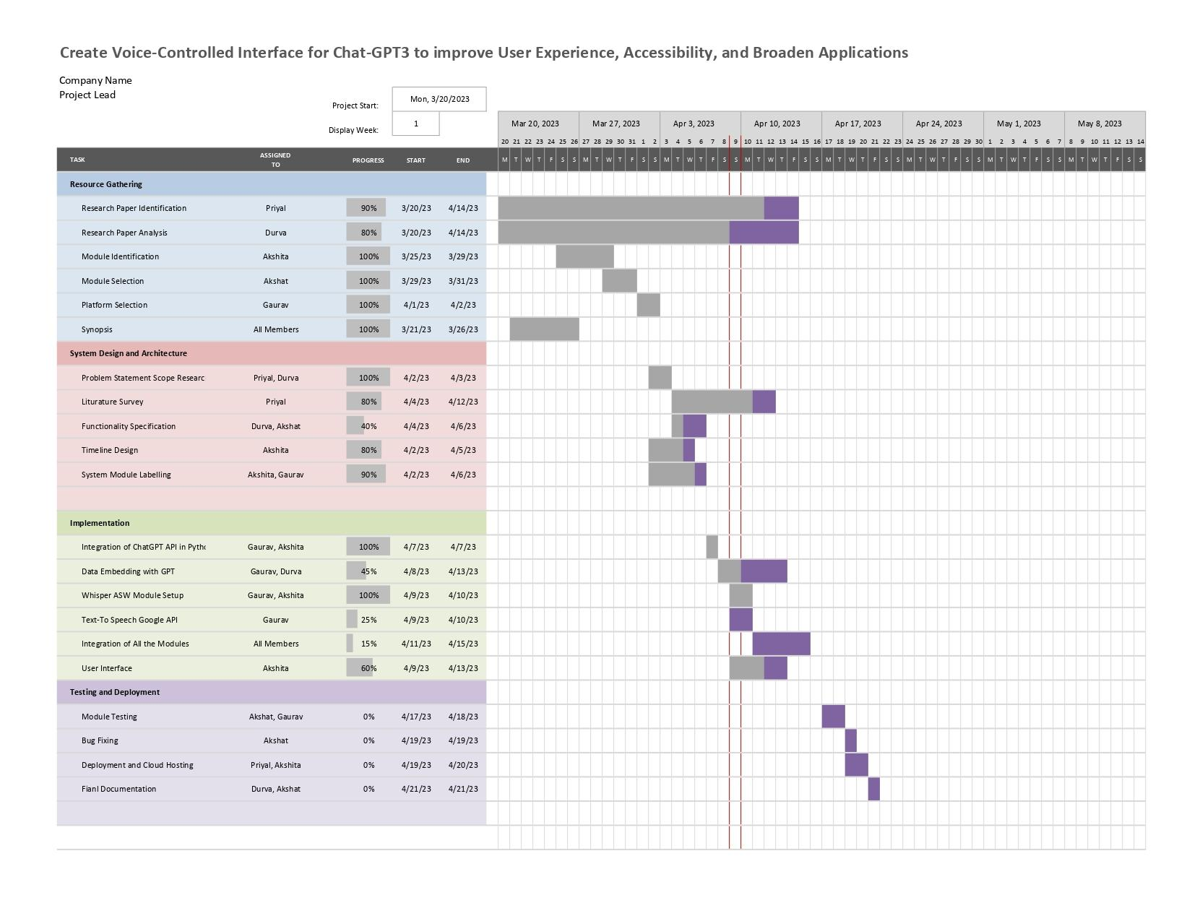

1. **Requirements Gathering**: Define the project requirements by understanding user needs, system functionalities, and technical constraints.
2. **System Analysis and Design**: Conduct a detailed analysis of the system requirements and design the system architecture, modules, and interfaces. Create low-level designs, including the block diagram.
3. **Implementation**: Develop the voice-controlled interface by integrating speech recognition and text-to-speech technologies. Implement error handling, security measures, and accessibility features.
4. **Testing**: Conduct thorough testing of the voice-controlled interface to ensure accuracy, performance, and usability. Identify and fix any issues or bugs.
5. **Integration and Deployment**: Integrate the voice-controlled interface with the Chat-GPT3 API or interface. Deploy the system to a cloud-based hosting solution for scalability and availability.
6. **User Acceptance Testing**: Conduct user acceptance testing to validate the system's functionality and usability from end-users' perspective.
7. **Documentation**: Create documentation, including user manuals, installation guides, and technical documentation, for reference and future maintenance.

Chapter 7

Implementation

1. Methodology
   1. Integrate speech recognition technology to enable voice input for **Chat-GPT3 interface**.
   2. Utilize Python modules such as SpeechRecognition or Google Cloud **Speech-to-Text** for speech recognition.
   3. Implement text-to-speech technology using Python modules like **gTTS or pyttsx3** for generating spoken responses from Chat-GPT3.
   4. Employ algorithms for **language identification**, **accent detection**, and **dialect recognition** to handle **diverse accents**, **dialects**, and **languages** in voice commands.
   5. Optimize speed and accuracy of **speech recognition and text-to-speech** processing to ensure smooth and efficient voice-controlled interactions with Chat-GPT3.
   6. Conduct thorough **testing and evaluation** to assess the performance and usability of the voice-controlled interface, and make necessary improvements based on feedback.
   7. Follow ethical guidelines for **data privacy and security**, **informed consent**, and **user consent** in accordance with relevant regulations and policies.
2. Algorithm
   1. Speech recognition algorithm (e.g., Hidden Markov Models, Deep Neural Networks, Convolutional Neural Networks) for converting voice input into text.
   2. Text-to-speech (TTS) algorithm (e.g., concatenative TTS, neural TTS) for generating spoken responses from text.
   3. Language identification algorithm for identifying the language of voice commands.
   4. Accent detection algorithm for detecting different accents in voice commands.
   5. Dialect recognition algorithm for recognizing regional dialects in voice commands.
   6. Optimization algorithms for improving the speed and accuracy of speech recognition and TTS processing.
   7. Evaluation metrics for assessing the performance and usability of the voice-controlled interface (e.g., accuracy, latency, user satisfaction).
   8. Ethical guidelines for data privacy and security, informed consent, and user consent compliance.
3. Implementation

Algorithm for conversion of Audio received through microphone into Text using Whisper AI

1. Import the required libraries - PyAudio, websockets, asyncio, base64, and json.
2. Set the variables for the audio recording - frames per buffer, format, channels, and rate.
3. Initialize the PyAudio object and open the audio stream for recording.
4. Define the URL for the AssemblyAI endpoint to be used for the websocket connection.
5. Create an asynchronous function called "send_receive".
6. Within "send_receive", establish a websocket connection with the AssemblyAI endpoint using the URL and an authorization key.
7. Receive the "SessionBegins" message from the websocket and print it.
8. Create two nested asynchronous functions: "send" and "receive".
9. Within "send", continuously read audio data from a stream in chunks of a specified size.
10. Encode the audio data in base64 format, convert it to a JSON string, and send it through the websocket.
11. Handle the exceptions thrown in case the connection is closed.
12. Within "receive", continuously receive and print the text data from the websocket.
13. Handle the exceptions thrown in case the connection is closed.
14. Run the event loop to execute the "send_receive" function.

Integration of Chat-GPT 3.5 into python using the session token key of the user.

1. Import the ChatGPT class from the pyChatGPT module.
2. Instantiate the ChatGPT class to create a new ChatGPT object.
3. Call the start_session method to start a new chat session and obtain a session token.
4. In a loop, prompt the user for a message, generate a response, and print the response.
   1. Prompt the user for a message.
   2. Call the generate_response method to generate a response.
   3. Print the response.
   4. If the user wants to end the chat session, break out of the loop.
5. Call the end_session method to end the chat session.

4. Snapshots

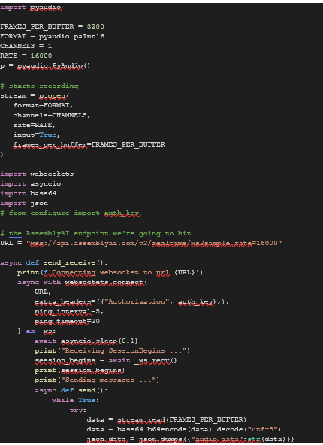

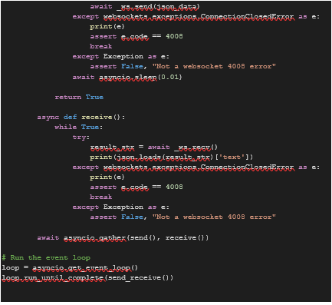

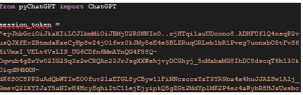

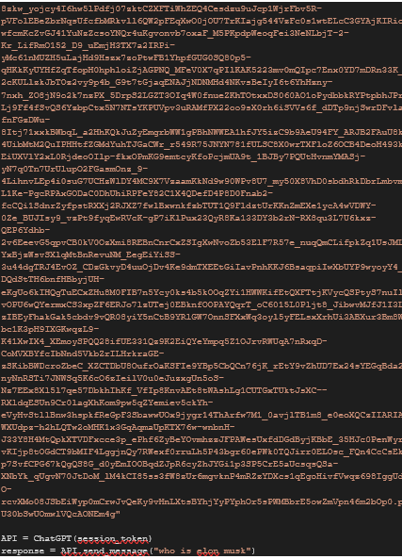



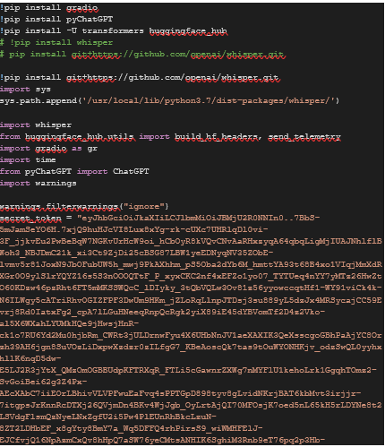

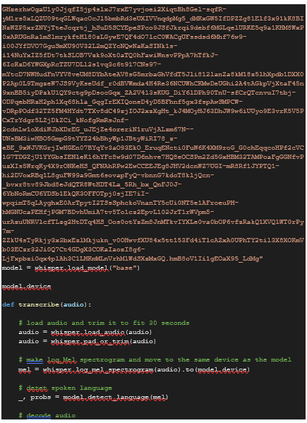

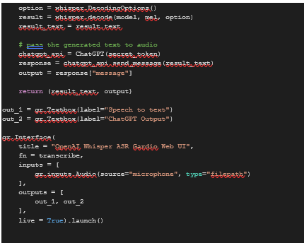

Chapter 8

Conclusion

Ultimately, the creation of a voice-controlled interface for Chat-GPT3 constitutes a big step forward in the field of natural language processing. This project intends to improve Chat-user GPT3's experience and accessibility by allowing users to engage with the language model via spoken instructions.

The successful deployment of this voice-controlled interface has the potential to completely transform how users engage with Chat-GPT3, making it more user-friendly and accessible for people of all abilities, including those with visual impairments or restricted mobility. This could provide new chances for a broader spectrum of users to benefit from Chat-GPT3 capabilities in areas like communication, education, and information retrieval.

Moreover, by incorporating speech recognition and text-to-speech technologies into this voice-controlled interface, Chat-GPT3 will be able to understand and respond to spoken commands in a wide range of accents, dialects, and languages. This will make the interface more accessible and relevant to users from various linguistic backgrounds, broadening its potential global applications.

Further improvements to this project could include the creation of a Chrome plugin that can be applied to a variety of websites and applications, as well as regular updates to the model with the most up-to-date information on specific domains. The ultimate purpose of this project is to provide a product that is inclusive, efficient, and improves accessibility for those with physical or visual disabilities, thus encouraging equal opportunity for all users.

References

[1] "Language Models are Few-Shot Learners" by Tom B. Brown et al. (2020): This is the original paper introducing GPT-3, describing its capabilities and performance in various tasks, including voice-based interactions.

[2] "Listen, Attend and Spell" by Chan, W., Jaitly, N., Le, Q., & Vinyals, O. (2016): This paper presents an attention-based speech recognition model that can be used for voice command recognition.

[3] "End-to-End Speech Recognition with Transformer" by Xuankai Chang et al. (2019): This paper discusses the application of the Transformer model, which is the underlying architecture of GPT-3, for speech recognition tasks, including voice command recognition.

[4] "Building Machines That Learn and Think Like People" by Josh Tenenbaum et al. (2017): This paper discusses the concept of "intuitive physics" and "intuitive psychology" as principles for building intelligent systems, including voice-activated AI, that can understand and respond to natural language commands.

[5] "Conversational AI: Dialogue Systems, Conversational Agents, and Chatbots" by Johannes Eichstaedt et al. (2021): This comprehensive book provides insights into various aspects of conversational AI, including voice-activated AI and voice command technologies, their applications, and challenges.

[6] "Speech Recognition with Deep Recurrent Neural Networks" by Alex Graves et al. (2013): This influential paper presents an early deep recurrent neural network (RNN) model for speech recognition, which could be relevant to voice command recognition in GPT-3.

[7] "Attention is All You Need" by Vaswani, A., Shazeer, N., Parmar, N., et al. (2017): This seminal paper introduces the Transformer architecture, which is the underlying architecture of GPT-3, and discusses the self-attention mechanism used for capturing long-range dependencies in sequences, including speech signals.

[8]"Improving Speech Recognition by Adaptive Training Data Selection" by Zhang, W., Li, K., & Yu, D. (2018): This paper presents an approach to adaptive data selection for training speech recognition models, which could be relevant for improving voice command recognition accuracy in GPT-3.

[9] "End-to-End Voice Command Recognition with Transformer Networks" by Huang, Z., & Lei, X. (2021): This recent paper proposes an end-to-end voice command recognition system based on the Transformer architecture, which could be relevant for integrating voice command capabilities into GPT-3.

[10] "Voice Assistant Technology and the Future of Human-Computer Interaction" by Clark, L., & Arifulina, S. (2020): This review paper provides insights into the current state of voice assistant technology, including voice command capabilities, and discusses future trends and potential applications in human-computer interaction.